By using Validation Controls, validation is done on both sides , client side & server side

How its done on client side ?? Because all validation controls have EnableClientScript property set to true

<%@ Page Language="C#" AutoEventWireup="true" CodeBehind="WebForm3.aspx.cs" Inherits="WebApplication3.WebForm3" %>

<!DOCTYPE html>

<html xmlns="http://www.w3.org/1999/xhtml">

<head runat="server">

<title></title>

<script>

function vaidateNameLength(sender, args) {

if (args.Value.length < 10)

args.IsValid = false;

else

args.IsValid = true;

}

</script>

</head>

<body>

<form id="form1" runat="server">

<div>

<asp:ValidationSummary ID="ValidationSummary1" runat="server" ShowMessageBox="True" />

Enter Name : <asp:TextBox ID="txtName" runat="server"></asp:TextBox>

<asp:RequiredFieldValidator ID="RequiredFieldValidator1" runat="server" ErrorMessage="*" ControlToValidate="txtName" ForeColor="Red"></asp:RequiredFieldValidator>

<%-- <asp:CustomValidator ID="CustomValidator1" runat="server" ErrorMessage="Minimum Length should be 10" ClientValidationFunction="vaidateNameLength" ControlToValidate="txtName" OnServerValidate="CustomValidator1_ServerValidate"></asp:CustomValidator>

--%>

<asp:CustomValidator ID="CustomValidator1" runat="server" ErrorMessage="Minimum Length should be 10" ControlToValidate="txtName" OnServerValidate="CustomValidator1_ServerValidate" ClientValidationFunction="vaidateNameLength"></asp:CustomValidator>

<asp:Button ID="btnSubmit" runat="server" Text="Submit" OnClick="btnSubmit_Click"></asp:Button>

&nbsp;&nbsp;&nbsp;&nbsp;&nbsp;&nbsp;&nbsp;&nbsp;&nbsp;&nbsp;&nbsp;&nbsp;&nbsp;&nbsp;&nbsp;&nbsp;&nbsp;&nbsp;&nbsp;&nbsp;&nbsp;&nbsp;&nbsp;&nbsp;&nbsp;&nbsp;&nbsp;&nbsp;&nbsp;&nbsp;&nbsp;&nbsp;&nbsp;&nbsp;&nbsp;&nbsp;&nbsp;&nbsp;&nbsp;&nbsp;&nbsp;

<br />

<br />

Enter Age :

<asp:TextBox ID="txtAge" runat="server"></asp:TextBox>

&nbsp;

<asp:RequiredFieldValidator ID="RequiredFieldValidator2" runat="server" ErrorMessage="Age is Required" ControlToValidate="txtAge" Display="Dynamic"></asp:RequiredFieldValidator>

&nbsp;<asp:RangeValidator ID="RangeValidator1" runat="server" ControlToValidate="txtAge" Display="Dynamic" ErrorMessage="Age should be in Range 20 - 30" MaximumValue="30" MinimumValue="20"></asp:RangeValidator>

<br />

<br />

<br />

Enter Password :

<asp:TextBox ID="txtPasssord" runat="server"></asp:TextBox>

<asp:RequiredFieldValidator ID="RequiredFieldValidator3" runat="server" ControlToValidate="txtPasssord" ErrorMessage="Password is must"></asp:RequiredFieldValidator>

<br />

<br />

Retype Password : <asp:TextBox ID="txtReTupePassword" runat="server"></asp:TextBox>

<asp:RequiredFieldValidator ID="RequiredFieldValidator4" runat="server" ControlToValidate="txtReTupePassword" Display="Dynamic" ErrorMessage="Retype Password Again"></asp:RequiredFieldValidator>

&nbsp;<asp:CompareValidator ID="CompareValidator1" runat="server" ControlToCompare="txtPasssord" ControlToValidate="txtReTupePassword" Display="Dynamic" ErrorMessage="Password do not match"></asp:CompareValidator>

<br />

<br />

Enter Score

<asp:TextBox ID="txtScore" runat="server"></asp:TextBox>

<%-- &nbsp;<asp:CompareValidator ID="CompareValidator2" runat="server" ControlToValidate="txtScore" ErrorMessage="Score should be more than 30" Operator="GreaterThan" Type="Integer" ValueToCompare="30"></asp:CompareValidator>

--%>&nbsp;<asp:CompareValidator ID="CompareValidator2" runat="server" ControlToValidate="txtScore" ErrorMessage="Score should be more than 30" Operator="GreaterThan" Type="Integer" ValueToCompare="30"></asp:CompareValidator>

<br />

<br />

Enter EMail

<asp:TextBox ID="txtEMail" runat="server"></asp:TextBox>

&nbsp;<asp:RegularExpressionValidator ID="RegularExpressionValidator1" runat="server" ControlToValidate="txtEMail" ErrorMessage="EMail format not correct" ValidationExpression="\w+([-+.']\w+)*@\w+([-.]\w+)*\.\w+([-.]\w+)*"></asp:RegularExpressionValidator>

</div>

</form>

</body>

</html>

using System;

using System.Collections.Generic;

using System.Linq;

using System.Web;

using System.Web.UI;

using System.Web.UI.WebControls;

namespace WebApplication3

{

public partial class WebForm3 : System.Web.UI.Page

{

protected void Page_Load(object sender, EventArgs e)

{

}

protected void btnSubmit_Click(object sender, EventArgs e)

{

if (Page.IsValid)

{

Response.Redirect("WebForm4.aspx");

}

}

protected void CustomValidator1_ServerValidate(object source, ServerValidateEventArgs args)

{

if (args.Value.Length < 10)

args.IsValid = false;

else

args.IsValid = true;

}

}

}

Custom Validator : When you want to put your own requirements or validations

<script>

  function CheckForLength(sender, args)

  {

  if (args.Value.length < 10) {

  args.IsValid = false;

  }

  else {

     args.IsValid = true;

  }

  return;

  }

 </script>

</head>

<body>

Web Form

<asp:Button ID="Button3" runat="server" Text="Button" />

Enter Name : <asp:TextBox ID="TextBox4" runat="server"></asp:TextBox>

<br />

<br />

<asp:CustomValidator ID="CustomValidator1"

ControlToValidate="TextBox4"

runat="server"  ClientValidationFunction="CheckForLength"

Text="MIn length is 10 "

ErrorMessage="CustomValidator" OnServerValidate="A1">

</asp:CustomValidator>

protected void A1(object source, ServerValidateEventArgs args)

{

int x = args.Value.Length;

if (x >= 10)

{

args.IsValid = true;

}

else

args.IsValid = false;

//args.IsValid = (args.Value.Length >= 10);

}

}

}

-----------------------------------------------------------------------------------------------------------

**Master Pages : are used to have same look and feel for all the pages**

**It is used to create a template**

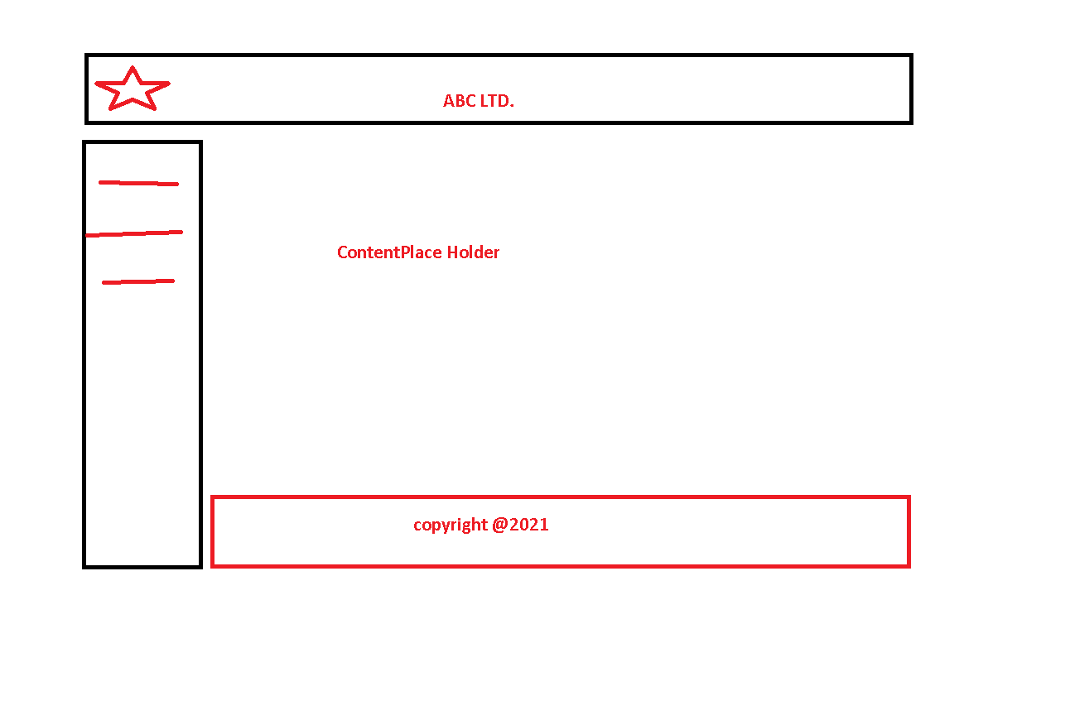

<%@ Master Language="C#" AutoEventWireup="true" CodeBehind="Main.master.cs" Inherits="WebApplication3.Main" %>

<!DOCTYPE html>

<html>

<head runat="server">

<title></title>

<asp:ContentPlaceHolder ID="head" runat="server">

</asp:ContentPlaceHolder>

</head>

<body>

<form id="form1" runat="server">

<div>

<asp:ContentPlaceHolder ID="ContentPlaceHolder1" runat="server">

</asp:ContentPlaceHolder>

</div>

</form>

</body>

</html>

<%@ Master Language="C#" AutoEventWireup="true" CodeBehind="Site.master.cs" Inherits="WebApplication3.Site" %>

<!DOCTYPE html>

<html>

<head runat="server">

<title></title>

<style type="text/css">

.auto-style1 {

width: 100%;

border: 2px solid #FF0000;

background-color: #FFFFFF;

}

.auto-style2 {

width: 299px;

}

</style>

</head>

<body>

<form id="form1" runat="server">

<div>

<table cellpadding="3" cellspacing="4" class="auto-style1">

<tr>

<td colspan="2">

<br />

<br />

<asp:Image ID="Image1" runat="server" Height="100px" ImageUrl="~/Images/Microsoft.jpg" />

&nbsp;&nbsp;&nbsp;&nbsp;&nbsp;&nbsp;&nbsp;&nbsp;&nbsp;&nbsp;&nbsp;&nbsp;&nbsp;&nbsp;&nbsp;&nbsp;&nbsp;&nbsp;&nbsp;&nbsp;&nbsp;&nbsp;&nbsp;&nbsp;&nbsp;&nbsp;&nbsp;&nbsp;&nbsp;&nbsp; <font size="7">&nbsp;&nbsp;&nbsp;&nbsp;&nbsp;&nbsp;&nbsp;&nbsp;&nbsp;&nbsp;&nbsp;&nbsp;&nbsp;&nbsp;&nbsp;&nbsp;&nbsp;&nbsp; ABC Ltd.</font></td>

</tr>

<tr>

<td class="auto-style2">

<asp:HyperLink ID="HyperLink1" runat="server" NavigateUrl="~/WebForm6.aspx">About Us</asp:HyperLink>

<br />

<asp:HyperLink ID="HyperLink2" runat="server" NavigateUrl="~/WebForm1.aspx">Contact Us</asp:HyperLink>

<br />

<asp:HyperLink ID="HyperLink3" runat="server" NavigateUrl="~/WebForm3.aspx">WebForm3</asp:HyperLink>

<br />

<asp:HyperLink ID="HyperLink4" runat="server">HyperLink</asp:HyperLink>

<br />

<asp:HyperLink ID="HyperLink5" runat="server">HyperLink</asp:HyperLink>

<br />

<asp:HyperLink ID="HyperLink6" runat="server">HyperLink</asp:HyperLink>

<br />

<asp:HyperLink ID="HyperLink7" runat="server">HyperLink</asp:HyperLink>

</td>

<td>&nbsp; <asp:ContentPlaceHolder ID="ContentPlaceHolder1" runat="server">

</asp:ContentPlaceHolder></td>

</tr>

<tr>

<td colspan="2">&nbsp;&nbsp;&nbsp;&nbsp;&nbsp;&nbsp;&nbsp;&nbsp;&nbsp;&nbsp;&nbsp;&nbsp;&nbsp;&nbsp;&nbsp;&nbsp;&nbsp;&nbsp;&nbsp;&nbsp;&nbsp;&nbsp;&nbsp;&nbsp;&nbsp;&nbsp;&nbsp;&nbsp;

<center> <footer> @coyright 2021 </footer>

</center> &nbsp;</td>

</tr>

</table>

</div>

</form>

</body>

</html>

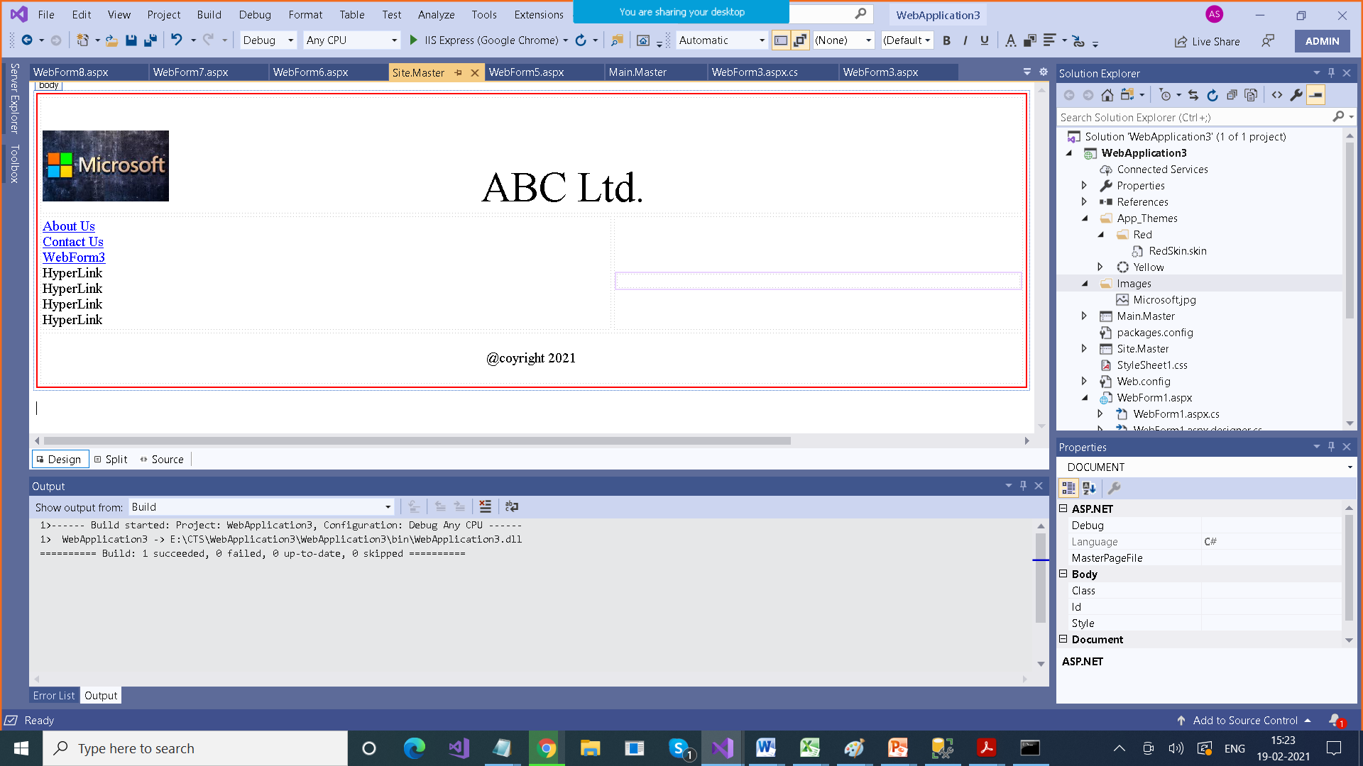

<%@ Page Title="" Language="C#" MasterPageFile="~/Site.Master" AutoEventWireup="true" CodeBehind="WebForm6.aspx.cs" Inherits="WebApplication3.WebForm6" %>

<asp:Content ID="Content2" ContentPlaceHolderID="ContentPlaceHolder1" runat="server">

<h1>About Us </h1>

<p>

Our senior leadership team has established and maintains a strong ethical climate, overseen by an independent Board of Directors. Our policies and practices reflect corporate governance initiatives that are compliant with the listing requirements of Nasdaq and the corporate governance requirements of Sarbanes-Oxley.

Our Corporate Governance policies reflect our core values.

</p>

</asp:Content>

<%@ Page Language="C#" AutoEventWireup="true" MasterPageFile="~/Site.Master" CodeBehind="WebForm3.aspx.cs" Inherits="WebApplication3.WebForm3" %>

<asp:Content ID="c2" ContentPlaceHolderID="ContentPlaceHolder1" runat="server">

<script>

function vaidateNameLength(sender, args) {

if (args.Value.length < 10)

args.IsValid = false;

else

args.IsValid = true;

}

</script>

<div>

<asp:ValidationSummary ID="ValidationSummary1" runat="server" ShowMessageBox="True" />

Enter Name : <asp:TextBox ID="txtName" runat="server"></asp:TextBox>

<asp:RequiredFieldValidator ID="RequiredFieldValidator1" runat="server" ErrorMessage="*" ControlToValidate="txtName" ForeColor="Red"></asp:RequiredFieldValidator>

<%-- <asp:CustomValidator ID="CustomValidator1" runat="server" ErrorMessage="Minimum Length should be 10" ClientValidationFunction="vaidateNameLength" ControlToValidate="txtName" OnServerValidate="CustomValidator1_ServerValidate"></asp:CustomValidator>

--%>

<asp:CustomValidator ID="CustomValidator1" runat="server" ErrorMessage="Minimum Length should be 10" ControlToValidate="txtName" OnServerValidate="CustomValidator1_ServerValidate" ClientValidationFunction="vaidateNameLength"></asp:CustomValidator>

<asp:Button ID="btnSubmit" runat="server" Text="Submit" OnClick="btnSubmit_Click"></asp:Button>

&nbsp;&nbsp;&nbsp;&nbsp;&nbsp;&nbsp;&nbsp;&nbsp;&nbsp;&nbsp;&nbsp;&nbsp;&nbsp;&nbsp;&nbsp;&nbsp;&nbsp;&nbsp;&nbsp;&nbsp;&nbsp;&nbsp;&nbsp;&nbsp;&nbsp;&nbsp;&nbsp;&nbsp;&nbsp;&nbsp;&nbsp;&nbsp;&nbsp;&nbsp;&nbsp;&nbsp;&nbsp;&nbsp;&nbsp;&nbsp;&nbsp;

<br />

<br />

Enter Age :

<asp:TextBox ID="txtAge" runat="server"></asp:TextBox>

&nbsp;

<asp:RequiredFieldValidator ID="RequiredFieldValidator2" runat="server" ErrorMessage="Age is Required" ControlToValidate="txtAge" Display="Dynamic"></asp:RequiredFieldValidator>

&nbsp;<asp:RangeValidator ID="RangeValidator1" runat="server" ControlToValidate="txtAge" Display="Dynamic" ErrorMessage="Age should be in Range 20 - 30" MaximumValue="30" MinimumValue="20"></asp:RangeValidator>

<br />

<br />

<br />

Enter Password :

<asp:TextBox ID="txtPasssord" runat="server"></asp:TextBox>

<asp:RequiredFieldValidator ID="RequiredFieldValidator3" runat="server" ControlToValidate="txtPasssord" ErrorMessage="Password is must"></asp:RequiredFieldValidator>

<br />

<br />

Retype Password : <asp:TextBox ID="txtReTupePassword" runat="server"></asp:TextBox>

<asp:RequiredFieldValidator ID="RequiredFieldValidator4" runat="server" ControlToValidate="txtReTupePassword" Display="Dynamic" ErrorMessage="Retype Password Again"></asp:RequiredFieldValidator>

&nbsp;<asp:CompareValidator ID="CompareValidator1" runat="server" ControlToCompare="txtPasssord" ControlToValidate="txtReTupePassword" Display="Dynamic" ErrorMessage="Password do not match"></asp:CompareValidator>

<br />

<br />

Enter Score

<asp:TextBox ID="txtScore" runat="server"></asp:TextBox>

<%-- &nbsp;<asp:CompareValidator ID="CompareValidator2" runat="server" ControlToValidate="txtScore" ErrorMessage="Score should be more than 30" Operator="GreaterThan" Type="Integer" ValueToCompare="30"></asp:CompareValidator>

--%>&nbsp;<asp:CompareValidator ID="CompareValidator2" runat="server" ControlToValidate="txtScore" ErrorMessage="Score should be more than 30" Operator="GreaterThan" Type="Integer" ValueToCompare="30"></asp:CompareValidator>

<br />

<br />

Enter EMail

<asp:TextBox ID="txtEMail" runat="server"></asp:TextBox>

&nbsp;<asp:RegularExpressionValidator ID="RegularExpressionValidator1" runat="server" ControlToValidate="txtEMail" ErrorMessage="EMail format not correct" ValidationExpression="\w+([-+.']\w+)*@\w+([-.]\w+)*\.\w+([-.]\w+)*"></asp:RegularExpressionValidator>

</div>

</asp:Content>

